THEORIC CONTENTS

* Lesson 3. Data Types.
* Lesson 4. Operators and Expressions.

GITHUB CLASSROOM ASIGNMENT

**https://classroom.github.com/a/yXFcewZ3**

PROPOSED EXERCISES

Exercise 1. Design and implement a C program that solves the next problem definition:

The program have to request to the user the coordinates of two points (x1,y1), (x2,y2) and calculate the geometrical distance. The formula is:

$${geometrical_distance}^{2}={({x_{2}-x}_{1})}^{2}+ {({y_{2}-y}_{1})}^{2}$$

**NOTE:** In C Language, to calculate the square root of a number must be included the math library by placing the following line of code: #include <math.h>

The function to compute square roots is sqrt (value). Example: int x, y=9; x = sqrt(y). In this case x will be 3.

Exercise 2. Design and implement a C program that solves the next problem definition:

The program has to request a lowercase character and show its uppercase character associated.

**NOTE:** There is always a constant distance between any corresponding uppercase and lowercase.

*Exercise 3.* Design and implement a C program that solves the next problem definition:

The program has to request to the user a magic number (integer). The magic number must be calculated by the user in this way:

1. The user has to think a secret number between 1 and 9.
2. The magic number is (age*10) – (secret_number*9)

With this magic number, the program can calculate automatically your age and the secret number. The units of the result is the secret number, while the user age is the sum of secret number and the left two digits.

Example (secret number is 8 and the age is 19):

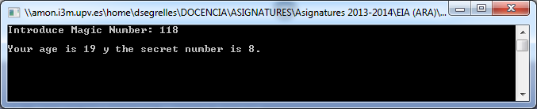

Exercise 4. Design and implement a C program that solves the next problem definition:

The program has to request for the full names of two people (mother and father). Each full name must be given in 3 different strings: first name, last name 1 and last name 2. The program will display the full name of the son/daughter, whose first name should be entered by the user.

Example:



Exercise 5*.* Design and implement a C program that solves the next problem definition:

The program has to display the quotient and reminder of an integer division, whose operands should be given by the user.

**

Exercise 6. Design and implement a C program that solves the next problem definition:

The program has to request to the user a character and show the next character represented in the ASCII table.

**NOTE:** ASCII Code is ordered in alphabetic order.

Example:

